TASK 1:

* Create a Vnet and set up a subnet on the created Vnet
* Create a VM on the subnet and access VM.

**Learning**:

**Virtual Network -** A virtual network is a networking system that emulates a physical network by combining the hardware and software network resources to form a single administrative unit.

**Subnet -** A subnet is a range of IP addresses in the virtual network.

Steps to Create Virtual Network and then create VM on subnet:

Step 1: Open Virtual network service inside Azure Portal and fill all details regarding it like Vnet name, region for its deployment, subnet IP range inside networking section etc.

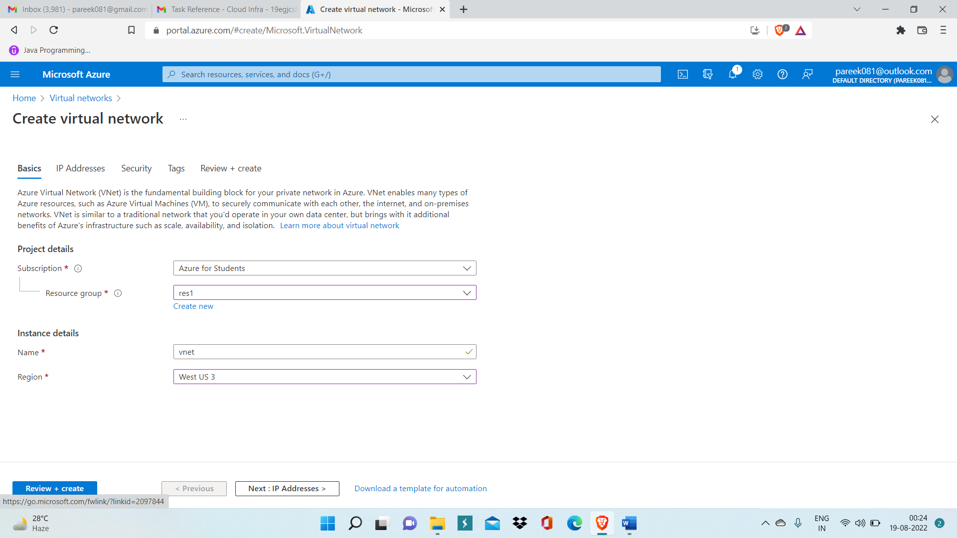

Step 2: After deployment, click on go to resources and open overview page.

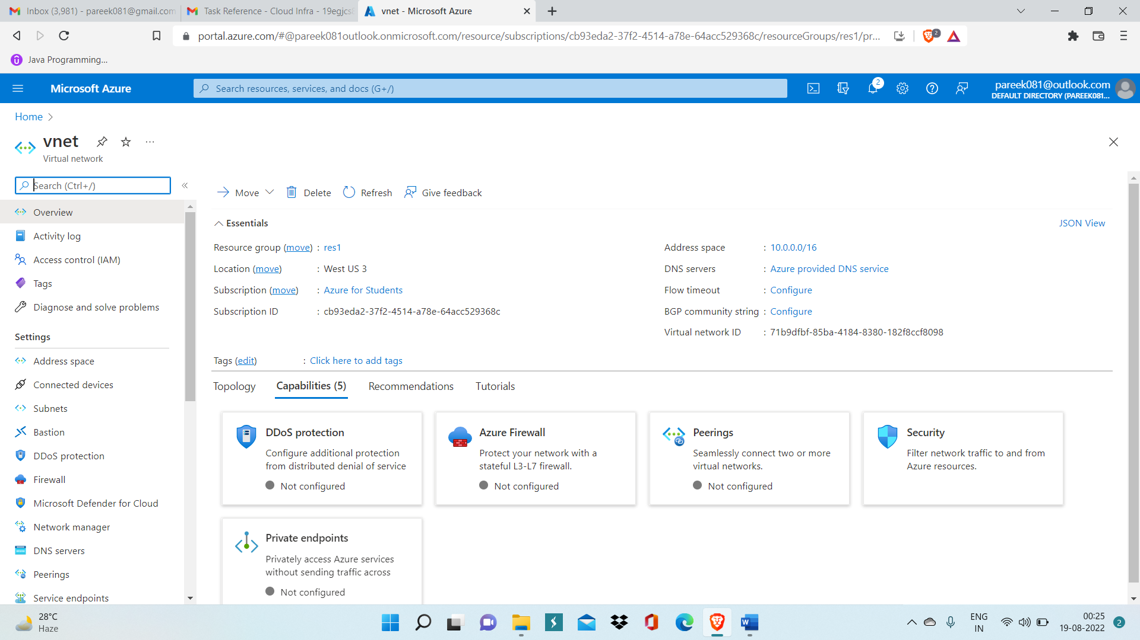

Step 3: Now open virtual machine service and create virtual machine. 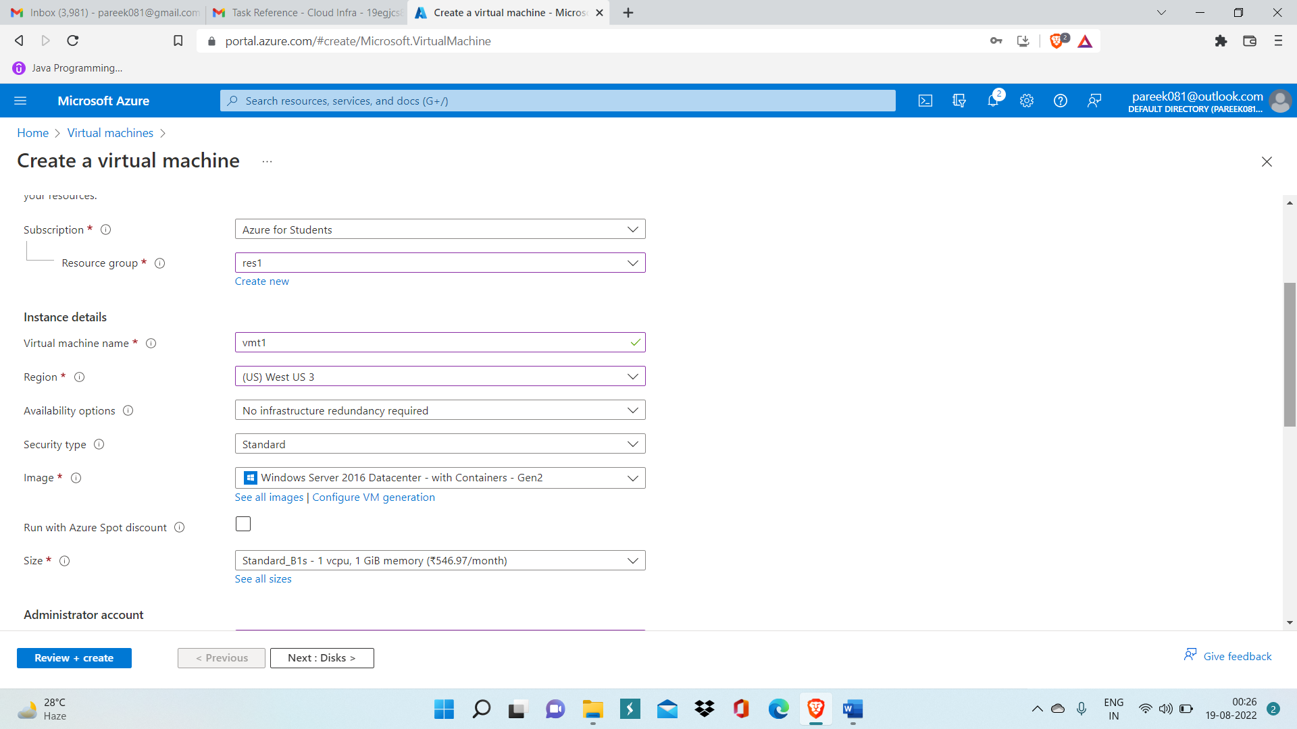

Step 4: Enter vm name, region, then, select region and at last click on review and create and then click on create.

After deployment, click on Go To Resource

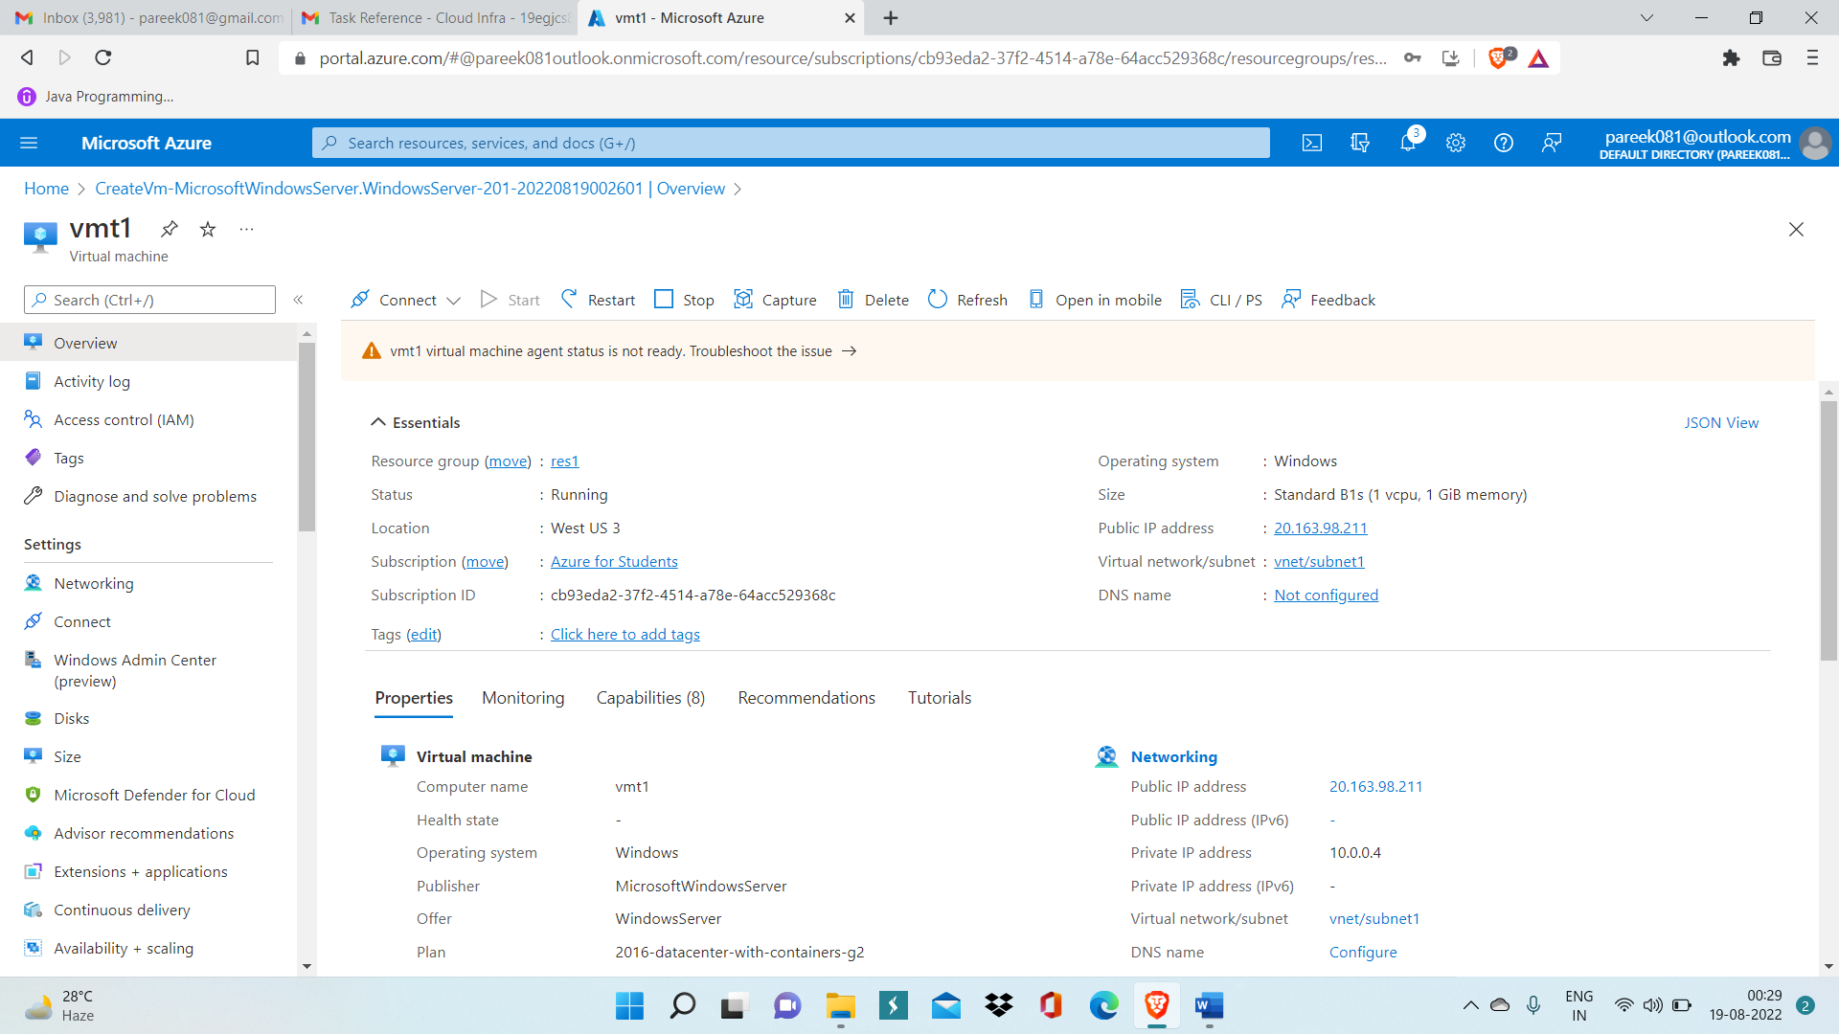

Step 5: Now select RDP option inside Connect dropdown menu and then download RDP file.

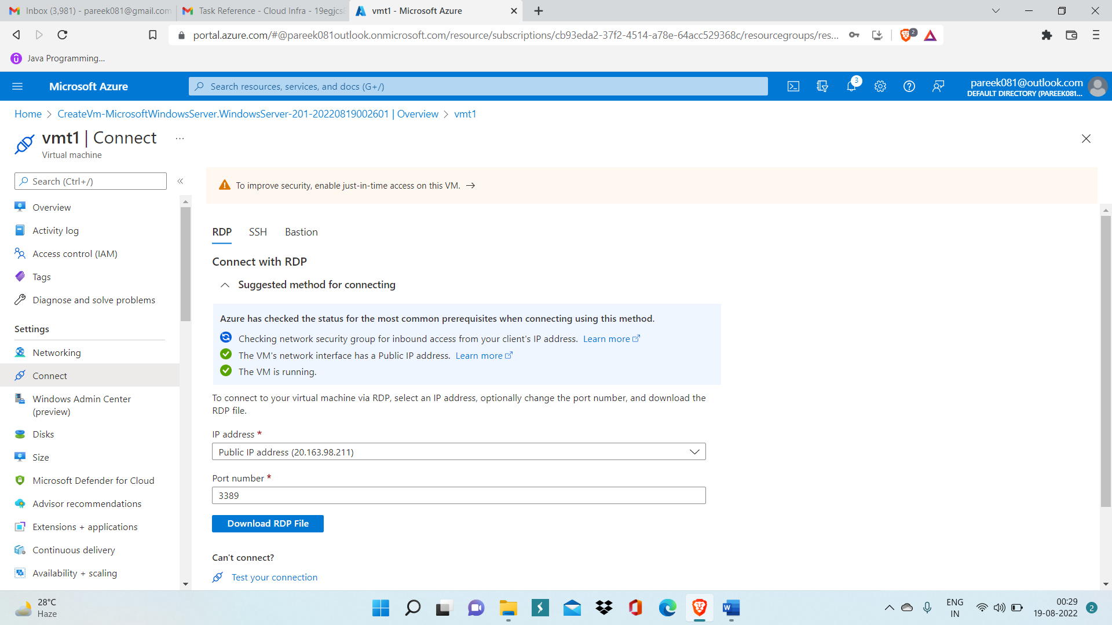

Step 6: After downloading RDP file open virtual machine and enter credentials like Username and Password.

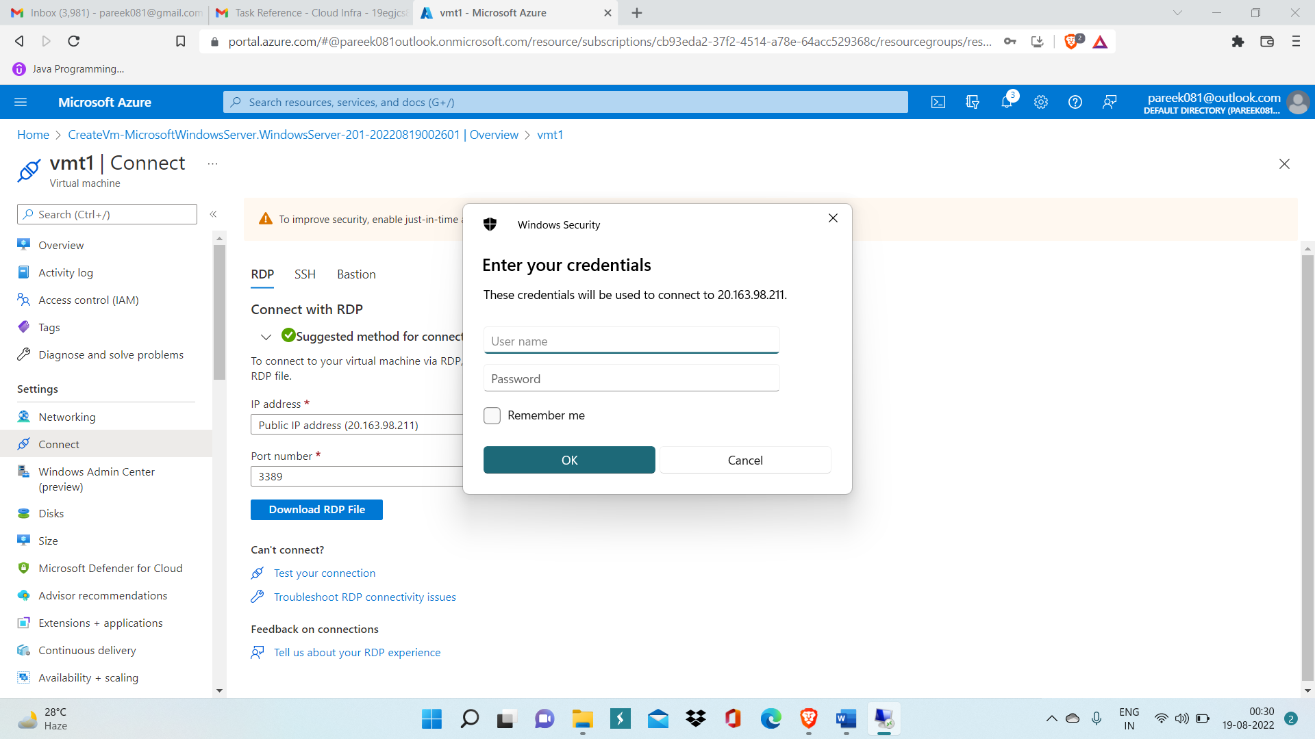

Step 7: Then, click ok and your VM will run on your machine.

